南开大学国际研究生申请材料要求

- 最高学历（学位）证书（证明）要求：
（1）应届毕业生可用《预毕业证明》代替最高学历（学位）证书进行申请。入学时，须提交毕业证书原件及中文（或英文）认证件以供查验。经验证不符合入学条件者，将被取消入学资格；
（2）我校认可的最高学历（学位）证书认证件应通过以下任一方式获得：
A.中国教育部留学服务中心出具的认证报告
仅限从中国大陆境外学校取得的学历
网址链接：http://zwfw.cscse.edu.cn/
B.中国教育部学位中心出具的认证报告
仅限从中国大陆境内学校取得的学历
网址链接：http://www.chinadegrees.cn/cn/
C.公证机构出具的公证件及中（英）文翻译件
D.本国驻华大使馆（代表处）或者中国驻外使领馆出具的中（英）文认证件

- 个人陈述模板

个人陈述
Personal Statement
基本信息
Personal Information
护照姓名  Passport Name |  | 护照号码  Passport No.
目前是否在中国境内  Within Chinese territory or not | 是（YES）  否(NO) | 是否接受线上授课  Whether accept online instruction or not | 是（YES）  否(NO)
申请陈述
Statement for Application
（建议可提供以下内容：来华学习和研究计划、家庭经济情况、奖学金申请原因、本人所获奖励和个人特长等；研究生申请人不少于800字，本科生申请人不少于300字）
（It is suggested to provide the following contents：a study or research plan, financial situation, reasons for scholarship application, honors and awards, personal strengths, etc; no less than 800 words for post graduate applicants, no less than 300 words for undergraduate applicants）

成绩和业绩（必填项，只填写最高学历）
Grade and Achievement (Required Fields，Highest Diploma only）
请填写原始GPA和原始GPA分制
Please fill in your Unconverted GPA grade value and GPA System
高中（High School）/本科（Bachelor）/硕士（Master）：
请填写转换后的4分制的GPA分值
Please fill in your Grade-Point Average using a 4-point system
高中（High School）/本科（Bachelor）/硕士（Master）：
请填写平均成绩，并说明评分体系
Please fill in your Average Grade，and explain the grading system
高中（High School）/本科（Bachelor）/硕士（Master）：
请填写成绩排名/总人数
Please fill in your Academic Ranking/ Number of the Students
高中（High School）/本科（Bachelor）/硕士（Master）：
请列出曾获荣誉、奖项、特殊贡献或发表的论文、专著。对于论文或专著，请提供完整的引文：
Please list any honors, awards, distinctions or publications. For publications, please provide the complete citation.
个人声明（必填项）
Personal Declaration(Required Fields)
- 你是否曾被留校察看、停学、退学或接受处分？
Have you ever been placed on probation，suspended，expelled or disciplined by any universities or institutions?
如果是，请解释/If yes, please explain.
- 你是否曾因任何犯罪被定罪（或现在正在针对你进行任何指控）？
Have you ever been convicted of (or is any charge currently pending against you for) any crime？
如果是，请解释/If yes, please explain.
我承诺个人陈述中的信息真实准确，由我本人独立完成。我知晓如有虚假不实信息，将被南开大学取消申请、录取及学习资格。
I promise that the information in my personal statement is true and accurate, and I completed it independently. I understand that if there is any false information, Nankai University will cancel my application, admission and study qualifications.

签名/Signature _____________________ 时间/Date ___________________
请将此表打印并手写签名，扫描成一个PDF文件上传至申请系统。
Please print this form and sign it, then scan it into a PDF file and upload it to the application system.

- 推荐信模板

南开大学国际学生推荐函
Letter of Recommendation
for International students of Nankai University

推荐学生基本信息
Personal Information of the Student
中文姓名  Chinese Name |  | 护照姓名  Passport Name |  |  | 国籍  Nationality
性别  Gender |  | 护照号码  Passport No. |  |  | 出生日期  Date of Birth
所在学校
Current School
推荐人基本信息
Personal Information of the Person Issuing the Recommendation
姓名  Full Name |  | 工作单位  Work Place |  |  | 职务  Position
电话  Phone No. |  |  | 邮箱  E-mail Address
推荐理由
Recommendation Reasons
该同学在同年级的学业综合排名为： 名，同年级学生人数为： 名,该同学学业综合表现占前百分之 （精确到小数点后两位）。
The student’s integrated academic grade ranking is: ;the number of students in the grade is: ;the comprehensive academic performance of the student accounts for the top percent (accurate to two decimal places).
注：中国境内中学，同年级排名基数为全体外国留学生；海外中学，排名基数为同年级全体学生。
Remark: The ranking base of the domestic high schools is all foreign students in the grade; the ranking base of overseas high schools is all students of the grade.
请从学生学业成绩、个人品行、综合素质、学术潜能、志趣抱负等方面，填写推荐理由
（可另附页）
Please write the recommendation reasons from the aspects of students' academic achievements, personal conduct, comprehensive quality, academic potential, aspiration, etc.
(use a separate page if necessary)

签名/Signature _____________________ 时间/Date ___________________
南开大学国际教育学院制

- 国际学生导师接收函模板
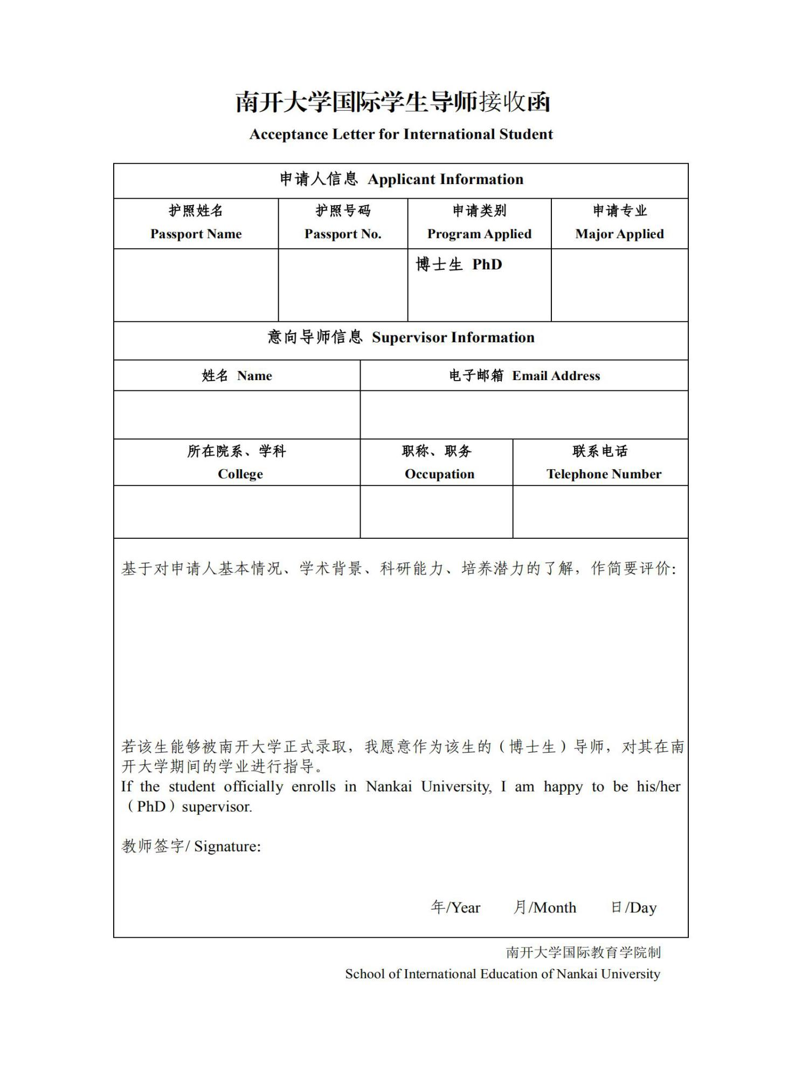
- 外国人体格检查记录模板
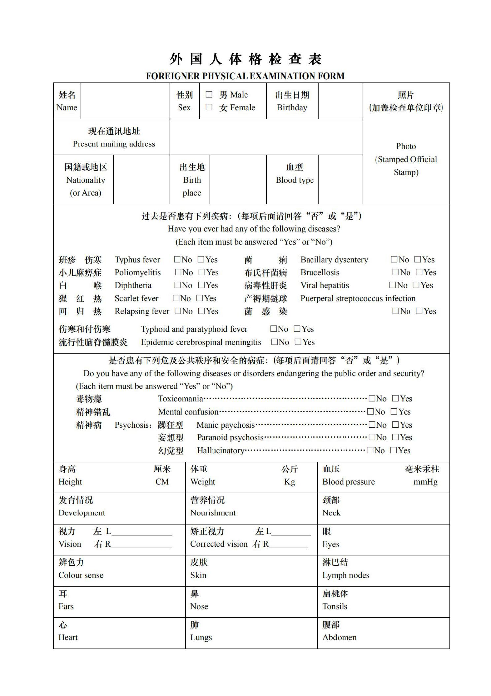
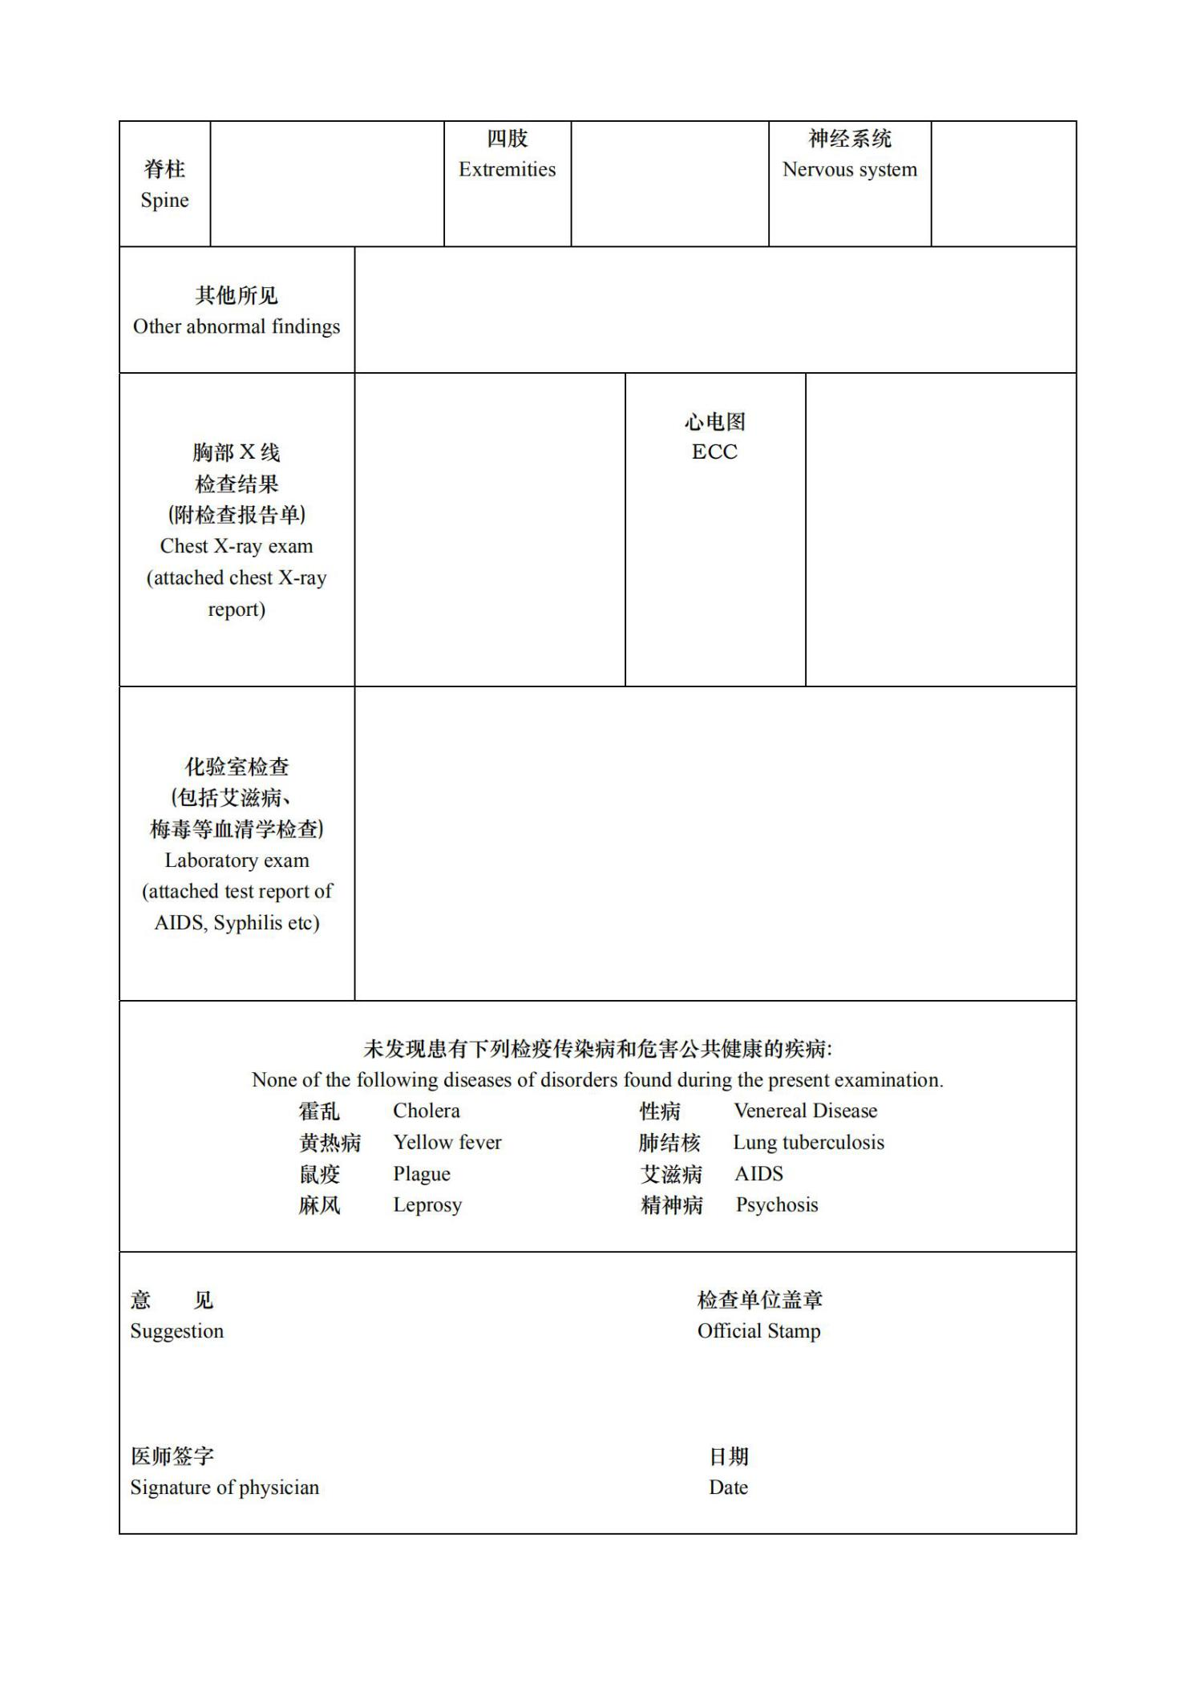
- 经济担保函模板

经济担保书

此担保书意在表明本人完全有能力并愿意支持 在中国学习期间的任何经济上的需要，本人的资助包他（她）在学习期间的学费，日常生活费以及国际旅行费用。

担保人：
日期：

Letter of Financial Guarantee

This is a letter of our intention to indicate that I have financial capability and are willing to support , during his/her stay in China to pursue studying and for whatever he/she may need financially. My support will include his/her tuition fees, living costs and travel expenses.
Guarantor:
Date:

